NAME SCHOOL
In developing your answers to Part III, be sure to keep these general definitions in mind:
- describe means “to illustrate something in words or tell about it”
- discuss means “to make observations about something using facts, reasoning, and argument; to present in some detail”
Part III

DOCUMENT-BASED QUESTION
This question is based on the accompanying documents (1–8). The question is designed to test your ability to work with historical documents. Some of the documents have been edited for the purpose of this question. As you analyze the documents, take into account the source of each document and any point of view that may be presented in the document.
Historical Context:
During the 1800s, the federal government promoted westward expansion in a variety of ways. This expansion changed the shape and character of the country.
Task: Using information from the documents and your knowledge of United States history, answer the questions that follow each document in Part A. Your answers to the questions will help write the Part B essay in which you will be asked to
- Describe the actions taken by the federal government that led to westward expansion during the 1800s
- Discuss the impact of westward expansion on the United States

Part A Short-Answer Questions
Directions: Analyze the documents and answer the short-answer questions that follow each document in the space provided.

Document 1
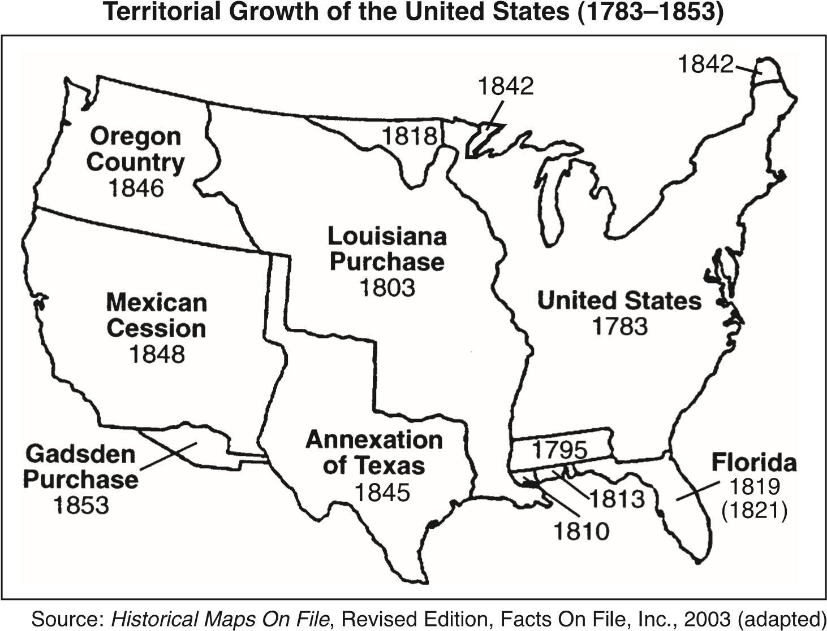
1 Based on the map, state two methods used by the United States government to acquire new territory. [2]
(1)____________________________________________________________________________________
____________________________________________________________________________________ Score
(2)____________________________________________________________________________________
____________________________________________________________________________________
Score

Document 2
An act to provide for an exchange of lands with the Indians residing in any of the states or territories, and for their removal west of the river Mississippi.
Be it enacted by the Senate and House of Representatives of the United States of America, in Congress assembled, That it shall and may be lawful for the President of the United States to cause so much of any territory belonging to the United States, west of the river Mississippi, not included in any state or organized territory, and to which the Indian title has been extinguished [revoked], as he [the president] may judge necessary, to be divided into a suitable number of districts, for the reception of such tribes or nations of Indians as may choose to exchange the lands where they now reside, and remove there; and to cause each of said districts to be so described by natural or artificial marks, as to be easily distinguished from every other. . . .
— Indian Removal Act of 1830
2 Based on this document, state one way that the Indian Removal Act of 1830 would affect many Native American Indians. [1]
____________________________________________________________________________________
____________________________________________________________________________________
Score

Document 3
. . . Instead of this, however, we have been exerting [putting forth] our best efforts to propitiate [gain] her [Mexico’s] good will. Upon the pretext that Texas, a nation as independent as herself, thought proper to unite its destinies with our own, she has affected to believe that we have severed [removed] her rightful territory, and in official proclamations and manifestoes has repeatedly threatened to make war upon us for the purpose of reconquering Texas. In the meantime we have tried every effort at reconciliation [restoring harmony]. The cup of forbearance [tolerance] had been exhausted even before the recent information from the frontier of the Del Norte [Mexican-American border]. But now, after reiterated [repeated] menaces, Mexico has passed the boundary of the United States, has invaded our territory and shed American blood upon the American soil. She has proclaimed that hostilities have commenced [begun], and that the two nations are now at war. . . .
— President James K. Polk, Message to Congress, May 11, 1846
3 Based on this passage, state one reason President Polk asked Congress to declare war on Mexico. [1]
____________________________________________________________________________________
____________________________________________________________________________________
Score

Document 4
. . . Regarding it as a war [Mexican War] to strengthen the “Slave Power,” we are conducted to a natural conclusion, that it is virtually, and in its consequences, a war against the free States of the Union. Conquest and robbery are attempted in order to obtain a political control at home; and distant battles are fought, less with a special view of subjugating [conquering] Mexico, than with the design of overcoming the power of the free States, under the constitution. The lives of Mexicans are sacrificed in this cause; and a domestic question, which should be reserved for bloodless debate in our own country, is transferred to fields of battle in a foreign land. . . .
— Resolution passed by the Massachusetts Legislature opposing the Mexican War; Massachusetts House Documents, 1847
4 According to this resolution, what was one reason the Massachusetts legislature opposed the Mexican War? [1]
____________________________________________________________________________________
____________________________________________________________________________________
Score

Document 5
Stephen Douglas replied to Abraham Lincoln’s question about the Kansas-Nebraska Act in a speech given at Freeport, Illinois. This reply occurred during the second debate in the political contest for the United States Senate seat from Illinois in 1858.
. . . The next question propounded [put forward] to me by Mr. Lincoln is, can the people of a Territory in any lawful way, against the wishes of any citizen of the United States, exclude slavery from their limits prior to the formation of a State Constitution? I answer emphatically, as Mr. Lincoln has heard me answer a hundred times from every stump [platform] in Illinois, that in my opinion the people of a Territory can, by lawful means, exclude slavery from their limits prior to the formation of a State Constitution. Mr. Lincoln knew that I had answered that question over and over again. He heard me argue the Nebraska bill [Kansas-Nebraska Act] on that principle all over the State in 1854, in 1855, and in 1856, and he has no excuse for pretending to be in doubt as to my position on that question. It matters not what way the Supreme Court may hereafter decide as to the abstract question whether slavery may or may not go into a Territory under the Constitution, the people have the lawful means to introduce it or exclude it as they please, for the reason that slavery cannot exist a day or an hour anywhere, unless it is supported by local police regulations. Those police regulations can only be established by the local legislature, and if the people are opposed to slavery they will elect representatives to that body who will by unfriendly legislation effectually prevent the introduction of it into their midst. If, on the contrary, they are for it, their legislation will favor its extension. Hence, no matter what the decision of the Supreme Court may be on that abstract question, still the right of the people to make a slave Territory or a free Territory is perfect and complete under the Nebraska bill. I hope Mr. Lincoln deems my answer satisfactory on that point. . . .
Source: Stephen Douglas, Freeport Doctrine, 1858
5 According to this document, how did the Kansas-Nebraska Act attempt to resolve the issue of slavery in the territories? [1]
____________________________________________________________________________________
____________________________________________________________________________________
Score

Document 6
. . . With the secession of Southern states from the Union and therefore removal of the slavery issue, finally, in 1862, the Homestead Act was passed and signed into law. The new law established a three-fold homestead acquisition process: filing an application, improving the land, and filing for deed of title. Any U.S. citizen, or intended citizen, who had never borne arms against the U.S. Government could file an application, improving the land and lay claim to 160 acres of surveyed Government land. For the next 5 years, the homesteader had to live on the land and improve it by building a 12-by-14 dwelling and growing crops. After 5 years, the homesteader could file for his patent (or deed of title) by submitting proof of residency and the required improvements to a local land office.
Local land offices forwarded the paperwork to the General Land Office in Washington, DC, along with a final certificate of eligibility. The case file was examined, and valid claims were granted patent to the land free and clear, except for a small registration fee. Title could also be acquired after a 6-month residency and trivial improvements, provided the claimant paid the government $1.25 per acre. After the Civil War, Union soldiers could deduct the time they served from the residency requirements. . . .
— National Archives and Records Administration, Teaching with Documents: The Homestead Act of 1862
6 According to this document, how did the Homestead Act encourage the settlement of the West? [1]
____________________________________________________________________________________
____________________________________________________________________________________
Score

Document 7
. . . Sec.2. And be it further enacted, That the right of way through the public lands be, and the same is hereby, granted to said company [The Union Pacific Railroad Company] for the construction of said railroad and telegraph line; and the right, power, and authority is hereby given to said company to take from the public lands adjacent to the line of said road, earth, stone, timber, and other materials for the construction thereof; said right of way is granted to said railroad to the extent of two hundred feet in width on each side of said railroad where it may pass over the public lands, including all necessary grounds for stations, buildings, workshops, and depots, machine shops, switches, side tracks, turn-tables, and water stations. The United States shall extinguish as rapidly as may be, the Indian titles to all lands falling under the operation of this act and required for the said right of way and grants hereinafter made.
Sec.3. And be it further enacted, That there be, and is hereby, granted to the said company, for the purpose of aiding in the construction of said railroad and telegraph line, and to secure the safe and speedy transportation of the mails, troops, munitions of war, and public stores thereon, every alternate section of public land, designated by odd numbers, to the amount of five alternate sections per mile on each side of said railroad, on the line thereof, and within the limits of ten miles on each side of said road, not sold, reserved, or otherwise disposed of by the United States, and to which a preëmption or homestead claim may not have attached, at the time the line of said road is definitely fixed: Provided, That all mineral lands shall be excepted from the operation of this act; but where the same shall contain timber, the timber thereon is hereby granted to said company. And all such lands, so granted by this section, which shall not be sold or disposed of by said company within three years after the entire road shall have been completed, shall be subject to settlement and preëmption, like other lands, at a price not exceeding one dollar and twenty-five cents per acre, to be paid to said company. . . .
— The Pacific Railroad Act, July 1, 1862
7a According to this document, what did the federal government give the Union Pacific Railroad Company to help them construct the railroad and the telegraph line? [1]
____________________________________________________________________________________
____________________________________________________________________________________
Score
b According to this document, how did the Pacific Railroad Act help the United States expand westward? [1]
____________________________________________________________________________________
____________________________________________________________________________________
Score

Document 8
“. . . The white man, who possesses this whole vast country from sea to sea, who roams over it at pleasure, and lives where he likes, cannot know the cramp we feel in this little spot, with the underlying remembrance of the fact, which you know as well as we, that every foot of what you proudly call America, not very long ago belonged to the red man. The Great Spirit gave it to us. There was room enough for all his many tribes, and all were happy in their freedom. But the white man had, in ways we know not of, learned some things we had not learned; among them, how to make superior tools and terrible weapons, better for war than bows and arrows; and there seemed no end to the hordes [huge numbers] of men that followed them from other lands beyond the sea.
“And so, at last, our fathers were steadily driven out, or killed, and we, their sons, but sorry remnants of tribes once mighty, are cornered in little spots of the earth all ours of right— cornered like guilty prisoners, and watched by men with guns, who are more than anxious to kill us off.
“Nor is this all. The white man’s government promised that if we, the Shoshones, would be content with the little patch allowed us, it would keep us well supplied with everything necessary to comfortable living, and would see that no white man should cross our borders for our game, or for anything that is ours. But it has not kept its word! The white man kills our game, captures our furs, and sometimes feeds his herds upon our meadows. And your great and mighty government – Oh sir, I hesitate, for I cannot tell the half! It does not protect us in our rights. It leaves us without the promised seed, without tools for cultivating the land, without implements [tools] for harvesting our crops, without breeding animals better than ours, without the food we still lack, after all we can do, without the many comforts we cannot produce, without the schools we so much need for our children. . . .”
— Chief Washakie of the Shoshone tribe from a speech to Governor John W. Hoyt of the Wyoming Territory, 1878
8 According to this document, what were two criticisms that Chief Washakie had against the white man and/or the federal government? [2]
(1)____________________________________________________________________________________
____________________________________________________________________________________ Score
(2)____________________________________________________________________________________
____________________________________________________________________________________
Score

Part B Essay
Directions: Write a well-organized essay that includes an introduction, several paragraphs, and a conclusion. Use evidence from at least five documents in your essay. Support your response with relevant facts, examples, and details. Include additional outside information.
Historical Context:
During the 1800s, the federal government promoted westward expansion in a variety of ways. This expansion changed the shape and character of the country.
Task: Using information from the documents and your knowledge of United States history, write an essay in which you
- Describe the actions taken by the federal government that led to westward expansion during the 1800s
- Discuss the impact of westward expansion on the United States
Guidelines:
In your essay, be sure to
- Address all aspects of the task by accurately analyzing and interpreting at least five documents
- Incorporate information from the documents in the body of the essay
- Incorporate relevant outside information
- Support the theme with relevant facts, examples, and details
- Use a logical and clear plan of organization
- Introduce the theme by establishing a framework that is beyond a simple restatement of the Task or Historical Context and conclude with a summation of the theme

